**GENERATING UNIT IMPULSE AND UNIT STEP SEQUENCES**

**LAB # 07**



**CSE301L Signals & Systems Lab**

Submitted by: **Shah Raza**

Registration No: **18PWCSE1658**

Class Section: **B**

“On my honor, as a student of University of Engineering and Technology, I have neither given nor received unauthorized assistance on this academic work.”

Student Signature: ______________

Submitted to: **Engr. Durr-e-Nayab**

Wednesday, July 15th, 2020

**Department of Computer Systems Engineering**

**University of Engineering and Technology, Peshawar**

**Lab Objectives:**

Objectives of this lab are as follows:

* Generating unit impulse and unit step sequences.
* Basic signal operations.

**Task # 1:**

Using ones function, plot the signum sequence over interval ‐10≤n≤10. It can be defined as:

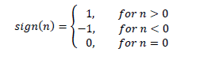

**Problem Analysis:**

Use ones and zeros functions to obtain the given signal.

**Code:**

n = -10:10;

x1=[-ones(1,10) zeros(1,1) ones(1,10)];

stem(n,x1,'filled');

axis([-10 10 -2 2]);

**Output:**

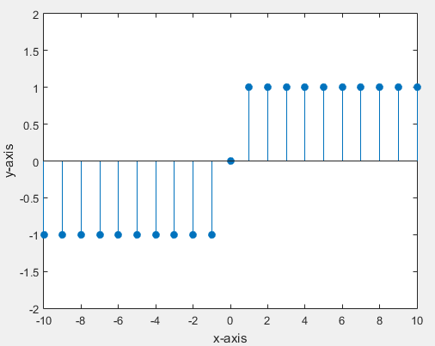

**Task # 2:**

Prove the following:



**Problem Analysis:**

To prove the given equation first generate a unit step signal and then subtract a shifted unit step signal from it.

**Code:**

n=-10:10;

u0=[zeros(1,10) ones(1,11)];

subplot(3,1,1);

stem(n,u0,'filled');

axis([-10 10 -1 1]);

title('u[n]');

u1=[zeros(1,11) ones(1,10)];

subplot(3,1,2);

stem(n,u1,'filled');

axis([-10 10 -1 1]);

title('u[n-1]');

u=u0-u1;

subplot(3,1,3);

stem(n,u,'filled');

axis([-10 10 -1 1]);

title('Result');

**Output:**

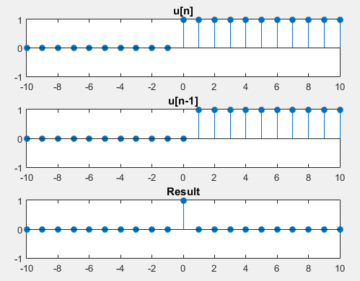

**Task # 3:**

Delay the original signal given in above example by 1 sec. Plot both the delayed & original signal on the same figure.

**Problem Analysis:**

To delay the signal by one unit, add one to the x-axis of the signal.

**Code:**

n=0:0.05:4;

x=sin(2*pi*1*n);

subplot(2,1,1);

plot(n,x,'linewidth',2);

title('Original Signal');

xlabel('Time');

ylabel('Signal Amplitude');

axis([-3 4 -1 1]);

grid;

subplot(2,1,2);

plot(n+1,x,'linewidth',2);

title('Delayed signal');

xlabel('Time');

ylabel('Signal Amplitude');

axis([-3 4 -1 1]);

grid;

**Output:**

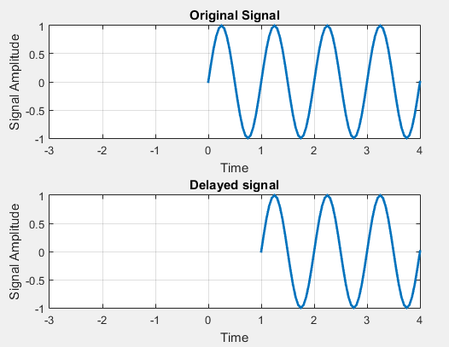

**Task # 4:**

Flip the following signal:



Plot the original signal as well as the flipped one in the same figure.

**Problem Analysis:**

To flip the given signal, multiply the x-axis of the signal to by minus.

**Code:**

n=-1:1/2000:1;

x1=5*exp(5*n*pi/4);

subplot(2,1,1);

plot(n,x1, 'g', 'linewidth',2);

axis([-1 1 -5 5]);

xlabel('time');

ylabel('signal amplitude');

title('Original sine wave');

grid;

subplot(2,1,2);

plot(-n,x1, 'r', 'linewidth',2);

axis([-1 1 -5 5]);

xlabel('time');

ylabel('signal amplitude');

title('Flipped sine wave');

grid;

**Output:**

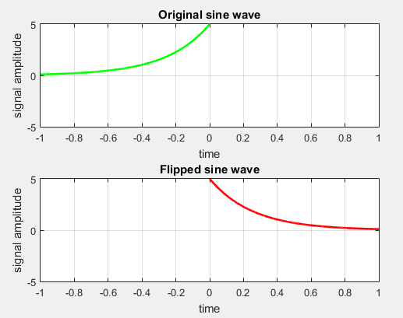

**Task # 5:**

Flip the following signal:

x[n]= 2δ[n]+ 5δ[n‐1] + 8δ[n‐2] + 4δ[n‐3] + 3δ[n‐4]

Plot the original signal as well as the flipped one in the same figure.

**Problem Analysis:**

Generate the signal as described above and then flip it.

**Code:**

n=-10:10;

x=[zeros(1,10) ones(1,1) zeros(1,10)];

x0=2*x;

x=[zeros(1,11) ones(1,1) zeros(1,9)];

x1=5*x;

x=[zeros(1,12) ones(1,1) zeros(1,8)];

x2=8*x;

x=[zeros(1,13) ones(1,1) zeros(1,7)];

x3=4*x;

x=[zeros(1,14) ones(1,1) zeros(1,6)];

x4=3*x;

xr=x0+x1+x2+x3+x4;

subplot(2,1,1);

stem(n,xr,'filled');

axis([-10 10 -10 10]);

title('Original Signal');

subplot(2,1,2);

stem(-n,xr,'filled');

axis([-10 10 -10 10]);

title('Flipped Signal');

**Output:**

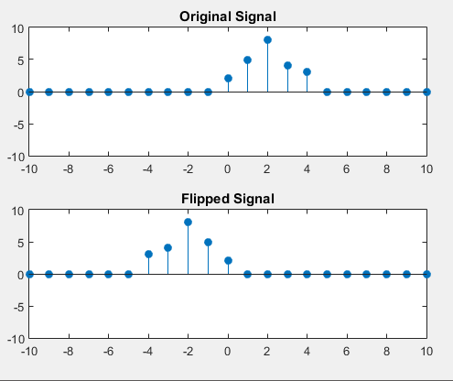

**Task # 6:**

Scale the continuous‐time sinusoid used in the signal shifting example by a factor of 2.

**Problem Analysis:**

To scale the amplitude of the signal, multiply the y-axis of the signal by the given factor.

**Code:**

n=0:0.002:4;

x=sin(2*pi*1*n);

subplot(2,1,1);

plot(n,x,'linewidth',2);

title('Original Signal');

xlabel('Time');

ylabel('Signal Amplitude');

axis([-3 4 -4 4]);

grid;

subplot(2,1,2);

S=2;

plot(n,S*x,'linewidth',2);

title('Scaled Amplitude Signal');

xlabel('Time');

ylabel('Signal Amplitude');

axis([-3 4 -4 4]);

grid;

**Output:**

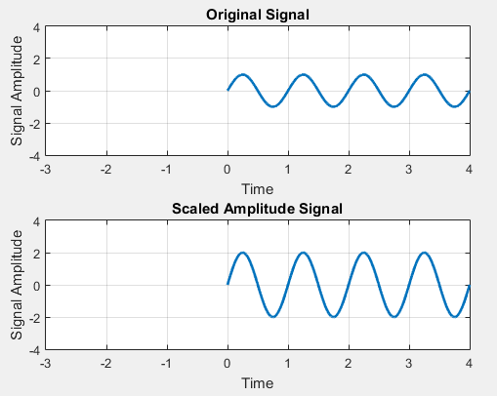

**Task # 7:**

Interpolate (up‐sample) the signal by a factor of 2.

**Problem Analysis:**

To interpolate the given signal use interp command.

**Code:**

n=-2:1/1000:2;

x1=sin(2*pi*2*n);

x2=interp(x1,2);

subplot(2,1,1);

plot(x1);

title('Original signal');

xlabel('Sample Number');

ylabel('Signal Amplitude');

axis([0 4000 -1 1]);

grid;

subplot(2,1,2);

plot(x2);

title('Interpolated Signal');

xlabel('Sample Number');

ylabel('Signal Amplitude');

axis([0 2000 -1 1]);

grid;

**Output:**

